Number Theory

6th Grade Unit

By:

Julie Cook, Park Rapids Century Middle School, [jcook2@parkrapids.k12.mn.us](mailto:jcook2@parkrapids.k12.mn.us)

Gabe Sturtz, Park Rapids Century Middle School, [gsturtz@parkrapids.k12.mn.us](mailto:gsturtz@parkrapids.k12.mn.us)

**Executive summary**

In this project, students will be able to find factors, prime factorization, greatest common factor and least common multiple. They will be able to manipulate items to discover various ways to find solutions. Students will use hot and cold cubes to explore rational numbers, compare rational numbers, work through order of operations, and the mathematical properties. In addition, students will solve real world problems by drawing pictures then writing equations, as well as solve magic squares and cryptarithms. They will be given time to explore each of these representations with their peers and share their thinking, which will guide them to deeper understanding.

**MN Math Standard(s):**

**6.1.1.2** Compare positive rational numbers represented in various forms. Use the symbols < , = and >.

**6.1.1.5** Factor whole numbers; express a whole number as a product of prime factors with exponents.

**6.1.1.6** Determine greatest common factors and least common multiples. Use common factors and common multiples to calculate with fractions and find equivalent fractions.

**6.1.3.4** Solve real-world and mathematical problems requiring arithmetic with decimals, fractions and mixed numbers.

**6.1.3.5** Estimate solutions to problems with whole numbers, fractions and decimals and use the estimates to assess the reasonableness of results in the context of the problem.

**6.2.2.1** Apply the associative, commutative and distributive properties and order of operations to generate equivalent expressions and to solve problems involving positive rational numbers.

**6.2.3.2** Solve equations involving positive rational numbers using number sense, properties of arithmetic and the idea of maintaining equality on both sides of the equation. Interpret a solution in the original context and assess the reasonableness of results.

**7.1.2.1** Add, subtract, multiply and divide positive and negative rational numbers that are integers, fractions and terminating decimals; use efficient and generalizable procedures, including standard algorithms; raise positive rational numbers to whole-number exponents.

Sample MCA questions

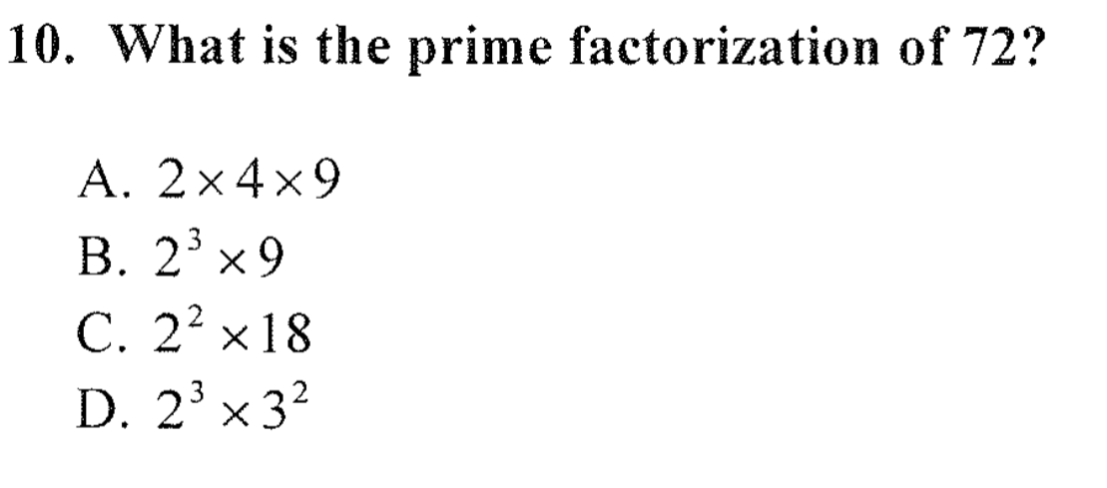

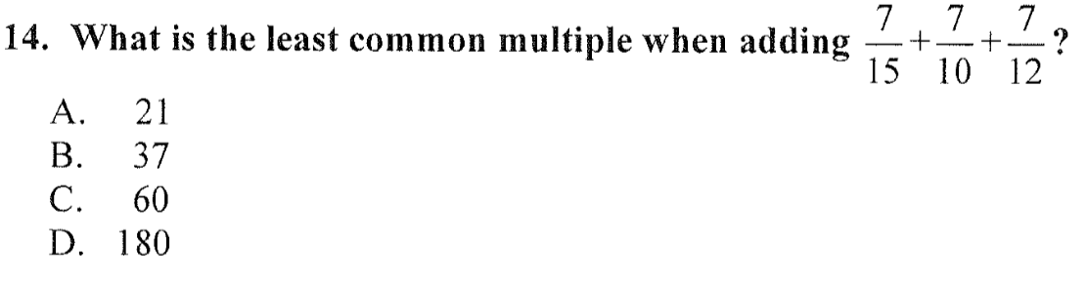

**Table of Contents**

**Pre-test 4 – 6**

**Unit 1**

**Factoring 7 –8**

**Prime Factorization 9 – 10**

**Greatest Common Factor 11 – 13**

**Least Common Multiple 14 – 17**

**Unit 2**

**Hot and Cold Cubes 18 – 21**

**Compare Rational Numbers 22 – 23**

**Order of Operations 24 – 33 Mathematical Properties 34 – 35**

**Unit 3**

**Solving Real World Problems 36 – 38**

**Magic Squares 39 – 41**

**Magic Squares – Decimals 42 – 44**

**Cryptarithms 45 – 47**

**Post-test 48 – 51**

**Number Theory Pre-Test**

1. Find all the factors for these integers:

12: _____________________________________________________________

32: _____________________________________________________________

100: ____________________________________________________________

2. Use a factor tree and write out the prime factorization of 176

3. Find the Greatest Common Factor for these sets of integers.

30, 6:

20, 12:

40, 18:

4. Find the Least Common Multiple for these sets of integers.

8, 5:

2, 3:

6, 10:

5. Compare these rational numbers:

1. 2 5 2. 0.03___ 0.003 3. 1.1 ___ 1.05

3 8

4. ⅖ ____ 0.44 5. 60% ____ ⅗ 6. 0.76 ___ 75%

6. Order these rational numbers from least to greatest:

⅛ , 23%, 0.11

________________________________________________________________

86%, 9/10, 0.89

________________________________________________________________

0.36, ⅓ , 35%

________________________________________________________________

7. You have of 1 ⅓ pounds of candy hearts. You put together small bags each weighing ⅛ of a pound. How many bags did you make? Draw a picture to solve and explain what your solution and any remainders means.

8. Solve

9. Name the property shown in each example.

____________________________________

____________________________________

____________________________________

10. Fill in missing numbers.

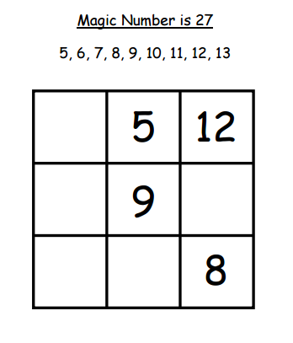

11. Write a story using hot and cold cubes. Draw a picture and show our solution.

12. Solve

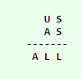

***Factoring***

**Objective:**

**6.1.1.5** Factor whole numbers; express a whole number as a product of prime factors with exponents.

**Launch:** Review from previous years the ideas of factors and how they are numbers that can be multiplied together to create a product. Go through examples with students in a whole group to help them discover that some numbers can have more than one set of factors.

**Explore:** Students will play an activity with a partner that will allow them to practice with factors. Pairs will start out playing with the game board of 30, but will have access to the game board of 49 if they finish early or would like to play at a later time.

The Factor Game Directions  
You need:  
• a partner  
• colored pencils in two different colors  
• The Factor Game board for 30 (see the next reproducible)  
Directions  
1. Player A chooses a number on the game board and circles it. This will be Partner A’s  
score for that round.  
2. Using a different color, Partner B circles all the proper factors of Player A’s number.  
The proper factors of a number are all the factors of that number except the number  
itself. Partner B lists the factors. The sum of those factors is Partner B’s score for that  
round.  
3. Player B then circles a new number. Player A circles all the remaining factors of that  
number. Then, play continues in this manner.  
4. The players take turns choosing numbers and circling factors.  
5. If a player circles a number that has no factors left which have not been circled, then  
that player does not get points for the number circled and loses his or her turn.  
6. The game ends when there are no more numbers left with factors that are not circled.  
7. The player with the larger sum of factors and products is the winner.  
Extension: Play a game on a 49 game board! (See the corresponding reproducible.)

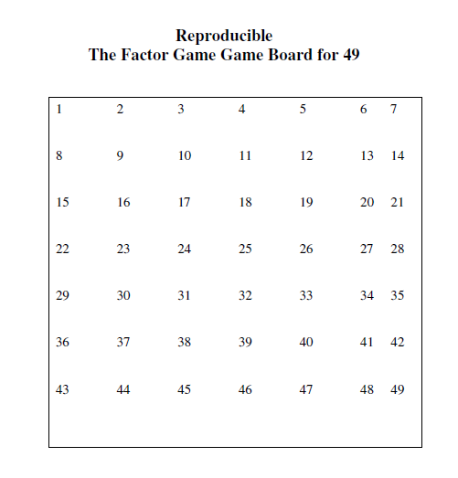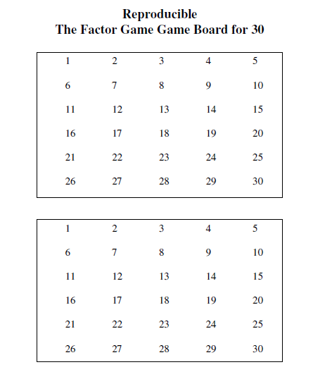

**Share:** Students will share strategies they developed for choosing numbers as they played. Have students share any difficulties or celebrations they had while they were playing with their partner.

**Summarize:** Discuss with students the different strategies they developed as they were playing the game. Review the concept of factors and how they are different from multiples, but both concepts will help later on in their math careers. Prime factorization is a big idea.

***Prime Factorization***

**Objective:** **6.1.1.5** Factor whole numbers; express a whole number as a product of prime factors with exponents.

**Launch:** Discuss prime numbers and composite numbers. Review factoring. Demonstrate prime factorization using a factor tree. Tell students we are going to have some competitions with prime factorizations.

**Explore:** Have 3-4 groups send one student to the whiteboard and have a contest finding the prime factorization, using factor trees, of a given number, however the first set of factors cannot be used by more than one group. (Can have help from group members). When a group sees that another group is using a repeated set of factor they buzz the group, the second group using the same factors must start over with a new set of factors. When completed look over everyone’s answer. They should be the same. Do this multiple times, while alternating groups. Allow each student to come to the board a minimum of 1 time.

**Share:** Discuss how students could get the same answer if they used different number.

**Summarize:** Review that there are multiple ways for students to get to the final answer, but there is only one final answer.

**Assignment:** Prime Factorization worksheet

Name: ________________________________________________ Date: ___________

Prime Factorization

Use factor trees to find the prime factorization of each number.

1. 36 2. 136

_______________ _______________

3. 256 4. 1025

_______________ _______________

***Greatest Common Factor***

**Objective:** **6.1.1.6** Determine greatest common factors and least common multiples. Use common factors and common multiples to calculate with fractions and find equivalent fractions.

**Launch:** Start the lesson by having students complete these problems individually. When they are finished, they can discuss the problems with their shoulder partners.

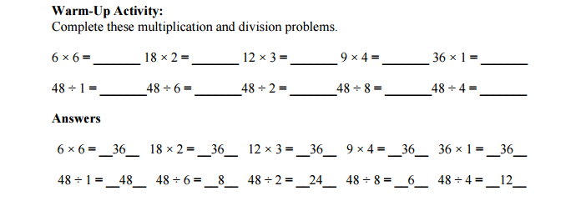

Discuss the idea of factors and how all of these are related with the class. Ask students to then write all the factors of 36 and 48 on the back of their sheets. Review the strategy from yesterday, and then ask students if they have any common factors between the two numbers. (List the common factors on the board) Now ask students to identify the Greatest Common Factor! This will lead into their activity they will play with their partners.

**Explore:**

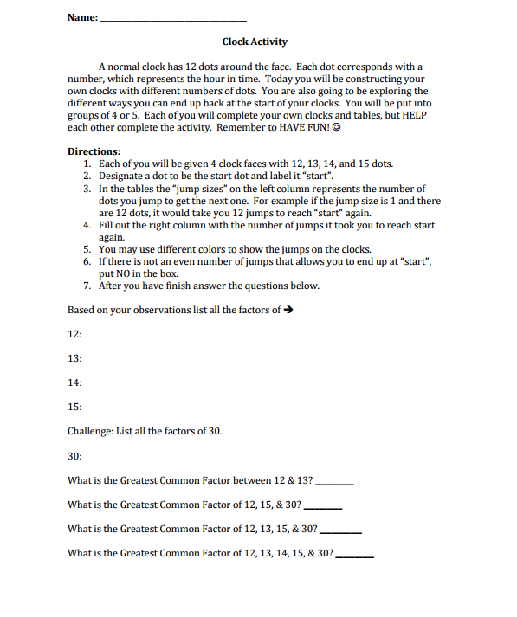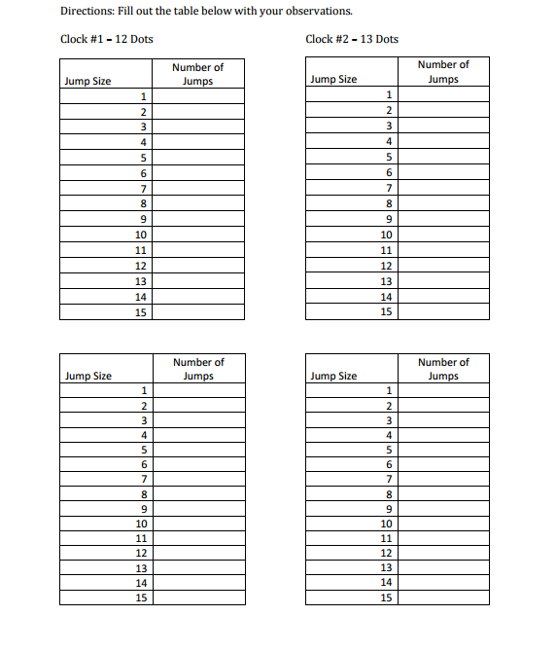

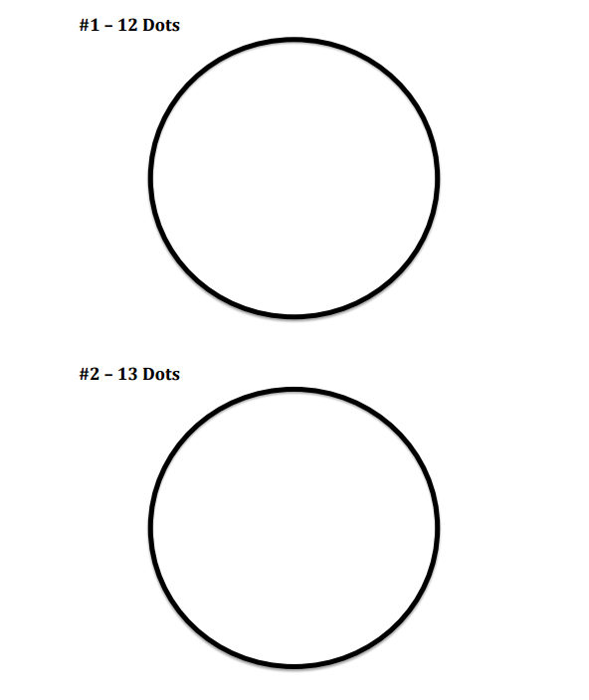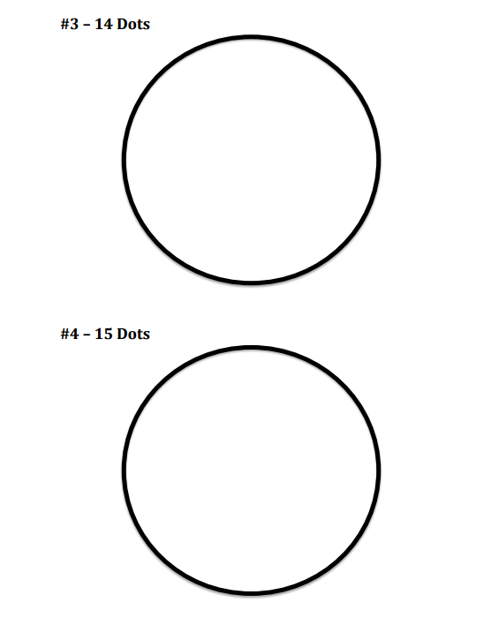

**Share:** Have students share what they discovered for the factors of each number. Allow students to explain their strategies for discovering the Greatest Common Factor. Students should share their GCF for sets of numbers.

**Summarize:** Be sure to distinguish the difference between multiples and factors and that today you were working with factors and how to discover the Greatest Common Factor. Leave students with the assessment that will be due tomorrow. These questions apply to real world situations.

**Assessment:**

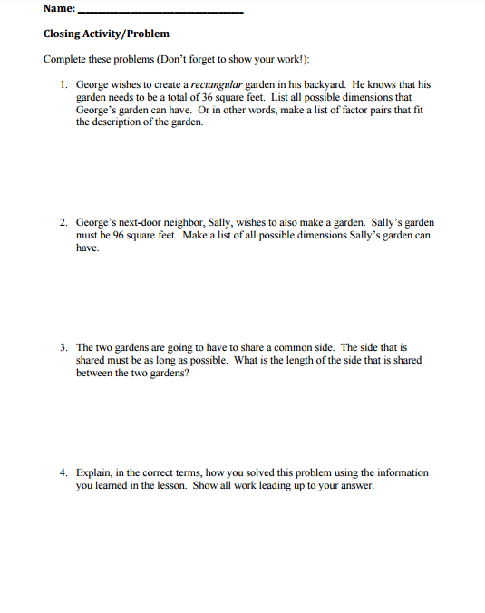

***Least Common Multiple***

**Objective:** **6.1.1.6** Determine greatest common factors and least common multiples. Use common factors and common multiples to calculate with fractions and find equivalent fractions.

**Launch:** Start the discussion with the idea of a multiple and how the word “multiple” is a base word for multiplication. So, we will start with a given number and see what numbers we can create by multiplying that given number. Move on from that idea to discuss how sets of numbers can have multiples in common (common multiples). More specifically, these sets of numbers can have a Least Common Multiple (a multiple the numbers share that is the least out of all their shared multiples). Go through an example for the set 4 and 6. Start by displaying the 100’s chart on the Smart Board, then skip counting by 4s until you have exhausted your list, do the same for 6s, but with a different color. Be sure to be using the word “multiple” frequently when marking these multiples. Then pose questions to students, such as: “What have we just marked? Do these two numbers share any multiples? What would be their Least Common Multiple?”

**Explore:** Share with students the activity: Multiple Madness. Go through the rules on the Smart Board, and use the 4 and 6 that you just did together as an example. Allow students to play with a partner.

**Share:** Pose these questions to students: Why is one of the rules for Multiple Madness to put the cards back in the pile and shuffle if both players draw the same number? (If they had the same number, they would all have the same multiples) How can understanding multiples help you with other mathematical concepts? (It will help with fractions, multiplication, division) Give an example. How many multiples can a number have? (Lists of multiples never end) Allow students to share any other discoveries they came upon while playing the activity.

**Summarize:** Discuss the meaning of the word: multiple. Tell students the list of multiples is never ending, and can be used to help with fractions and other math calculations later on in life as well.

**Multiple Madness**  
  
**Materials**  
*Number Cards for Multiple Madness (attached)  
*Multiple Madness Hundred Chart (attached)  
*Multiple Madness Recording Sheet (attached)  
*Game markers (e.g., checkers, colored chips, colored cubes) in two different colors

**Vocabulary**  
multiples, common multiples, least common multiple (LCM), multiplication/division related facts

Student/Teacher Actions (what students and teachers should be doing to facilitate learning)  
  
1. Point out to students that the word multiple is the root word of the word multiplication.  
Ask students what multiple means. Explain that they are going to explore multiples of  
different numbers and find common multiples of two different numbers. Have students  
discuss the meaning of the word common and the term common multiples.

2. Model how to identify multiples of a number and common multiples of two numbers. For example, begin with the numbers 4 and 6. Display a hundred chart, and have the class guide you in identifying all the multiples of 4 and marking them with one color. Next, without removing the identified multiples of 4, have the class guide you in identifying all the multiples of 6 and marking them with a different color. The multiples that are marked in both colors are common multiples of 4 and 6.

3. Lead a discussion about common multiples, and have students list the common multiples of 4 and 6 in order from least to greatest. Discuss least common multiple, also known as LCM.  
4. Distribute copies of the Multiple Madness Recording Sheet. Put students into pairs, and give each pair a set of number cards, a hundred chart, and two piles of colored game markers in two different colors. Have students play the Multiple Madness game as follows:  
Each player gathers a pile of colored game markers in a color different from that of  
his/her opponent.  
  
*Player 1 draws a number card from the pile and identifies the multiples of that number  
by marking them on the hundred chart with his/her colored game markers. He/she also  
records the multiples of the number at the bottom of the hundred chart.  
*Player 2 draws a number card and repeats the same steps.  
If a player draws a previously drawn number, the player places the card back in the pile,  
shuffles the pile, and draws again.  
*Once players have identified and recorded the multiples of their numbers, they  
compare multiples and fill in a Venn diagram on the recording sheet. They also find the  
least common multiple—i.e., the smallest number in the overlapping parts of the two  
circles.  
5. Discuss with the class things they discovered about the multiples of the pairs of numbers.  
Then, have students repeat the game, filling in their individual recording sheets to show  
their work.

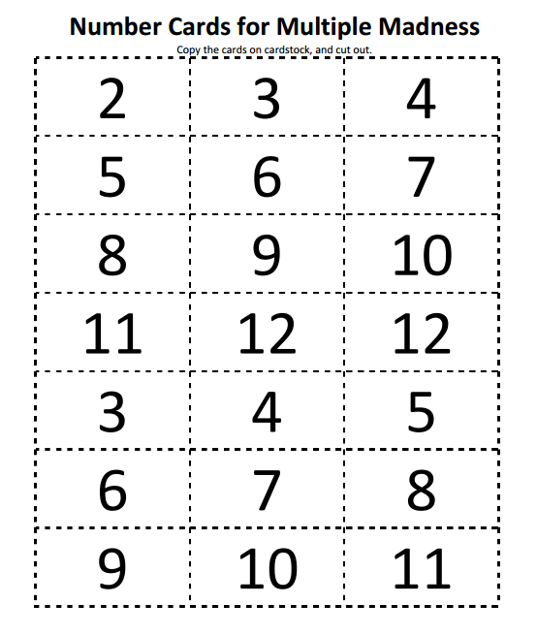

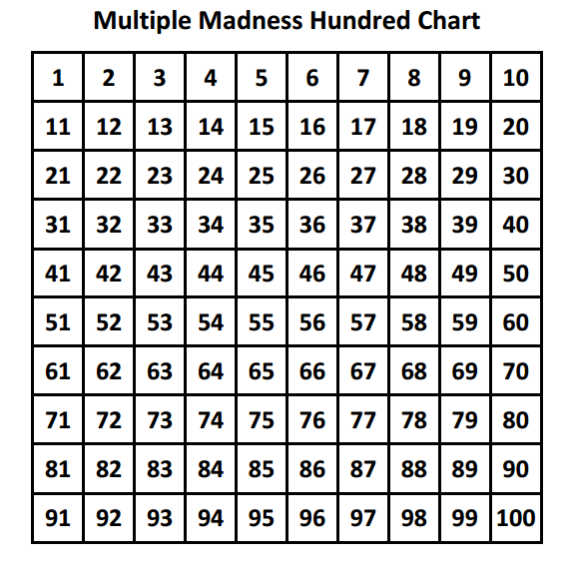

***Hot and Cold Cubes - Adding and Subtracting***

**Objective:** **7.1.2.1** Add, subtract, multiply and divide positive and negative rational numbers that are integers, fractions and terminating decimals; use efficient and generalizable procedures, including standard algorithms; raise positive rational numbers to whole-number exponents.

**Launch:** Tell the following story:

Hansel & Gretel have been caught by the evil witch and she has placed them in a cauldron. The evil witch intends to cook the kids but they intend to not be cooked before they escape. There are hot and cold cubes that are being added. The evil witch adds more and more hot cubes to bring the temperature up to cook the kids while Hansel and Gretel add cold cubes to bring the temperature back down.

Using hot and cold cube blocks, blue are cold cube blocks - cooling the liquid down as it is added to the pot and red are hot cube blocks - warming up the liquid as it is added to the pot. Work out this problem together

If the evil witch adds 3 hot cubes and then adds 6 more what would be the change in temperature inside the cauldron?

This can be represented by +3 + +6. Draw and show that you are adding the cubes into a cauldron to model this problem. Discuss the solution and what it means in terms of the liquid and net gain or loss. Try another problem: The witch takes a break and Hansel and Gretel put in 3 cold cubes and 9 more cold cubes. How can this be represented numerically?

**Explore:** Have students work through this problem in the groups. Have them come up with a numerical representation, drawing, and solution. Give students additional questions, one at a time, and have groups model them with their cold cubes and with a drawing. What happens when you have to take away more than you have? Talk about zero pairs and what this means and how you show it.

**Share:** Rotate through the groups and have them show their drawing for the rest of the class to see. Discuss any situations that come up that cause some problems. Answer questions that have come up.

**Summarize:** Discuss how negative numbers change the way we think about numbers and how they can cause confusion. Brainstorm ways to help understand how to work with negative numbers in hopes to create less confusion as we go on.

**Assignment:** Cold Cube - Addition and Subtraction worksheet

Name: ________________________________________________ Date: ___________

Cold Cubes - Addition and Subtraction

Use a drawing to find the solution to each problem.

1. +4 + +3 = _____ 2. -5 + +3 = ______

 

3.  -4 - +3 = _____ 4. -7 - -5 = ______

 

5.  -8 + +3 = _____ 6. -2 - -6 = ______

 

***Hot and Cold Cubes - Multiplying***

**Objective:** **7.1.2.1** Add, subtract, multiply and divide positive and negative rational numbers that are integers, fractions and terminating decimals; use efficient and generalizable procedures, including standard algorithms; raise positive rational numbers to whole-number exponents.

**Launch:** Discuss what positive and negative numbers mean. Pass out hot and cold cube blocks again, blue are cold cube blocks - cooling the liquid down as it is added to the pot and red are hot cube blocks - warming up the liquid as it is added to the pot. Work out this problem together +3 * +2. Drawing and showing that you are adding the cubes into a pot to model this problem. Discuss the solution and what it means in terms of the liquid and net gain or loss. Try another problem -2* -9. Have a group draw on the board what they did to find their solution.

**Explore:** Give students additional questions, one at a time, and have groups model them with their cold cubes and with a drawing.

**Share:** Rotate through the groups and have them show their drawing for the rest of the class to see. Discuss any situations that come up that cause some problems. Answer questions that have come up.

**Summarize:** Discuss the rules with multiply positive and negative numbers. Come up with a list of sign multiplication + * + = +, - * - = -, etc. Brainstorm ways to help understand how to work with negative numbers in hopes to create less confusion as we go on.

**Assignment:** Cold Cube - Multiplication worksheet

Name: ________________________________________________ Date: ___________

Cold Cubes - Multiplication

Use a drawing to find the solution to each problem.

1. +4 * +2 = _____ 2. -5 * +2 = ______

 

3.  -2 * +2 = _____ 4. -4 * -5 = ______

 

5.  -8 * -1 = _____ 6. -2 * -6 = ______

 

***Compare Rational Numbers***

**Objective:** **6.1.1.2** Compare positive rational numbers represented in various forms. Use the symbols <, = and >.

**Launch:** Start by reviewing simple conversions of percents → decimals → fractions. Start with 25% → 25/100 → 1/4 → .25 to access students’ prior knowledge of rational numbers. Engage students by letting them know they are going to create a dream team! Use the basketball activity to allow students to create a team while ordering rational numbers.

**Explore:**

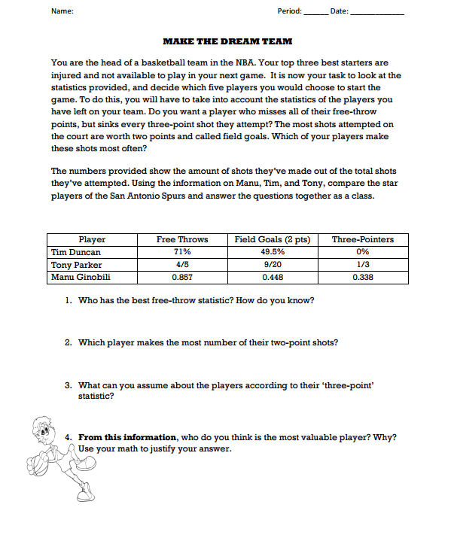

Once students are finished answering the questions given, allow them time to wander the room to compare their answers with classmates.

**Share:** Ask for volunteers to share their answers and how they came to the conclusions they made. Tell students that sports are not the only place where we must convert rational numbers. Ask students to think of different places where they may have to convert these numbers.

**Summarize:** Go through students’ reasons for their answers for the activity, and reinforce the idea that conversions are found commonly in the real world (shopping, taxes, money in general) Allow students to work with a partner on their assessment.

**Assessment:** Make Your Own Dream Team!

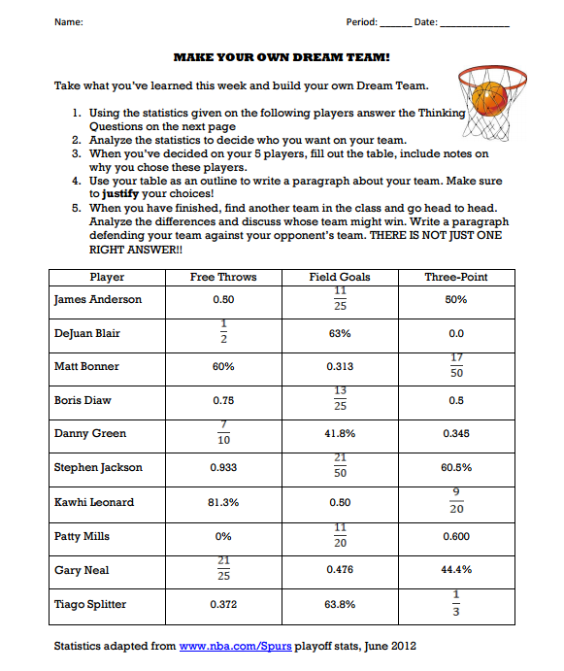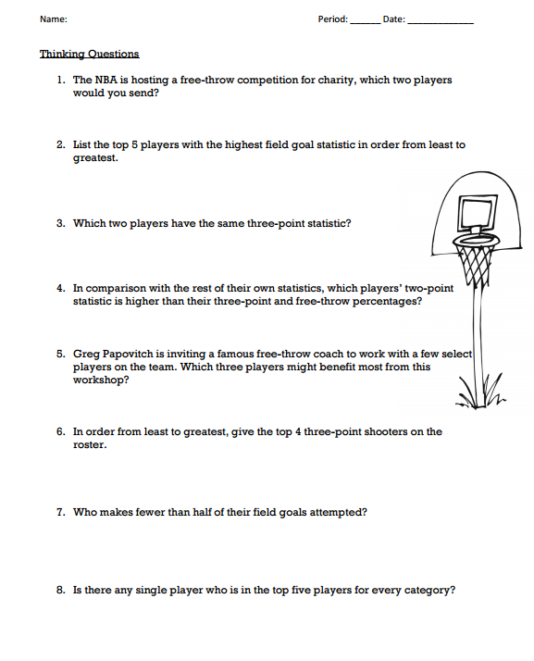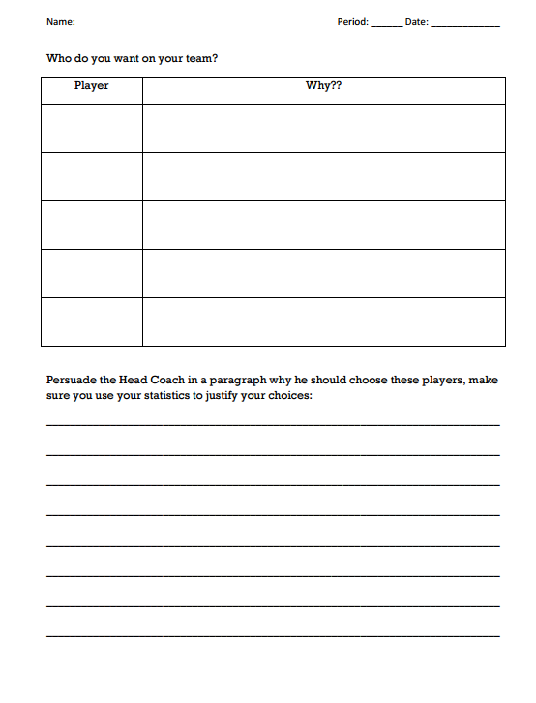

***Order of Operations - Footloose***

**Objective:** **6.2.2.1** Apply the associative, commutative and distributive properties and order of operations to generate equivalent expressions and to solve problems involving positive rational numbers.

**Launch:** Tell students we are going to play Footloose. Give each student one of the 30 cards. If there are extra cards, they can be placed around the room for students to pick up as needed. If there are more than 30 students, students may share cards as they work.

**Explore:** Students should note which card they are starting with (put a star on their grid paper in the box they start in) and then answer the question on their first card by writing the answer on their grid (not on the card), in the box with the number that corresponds to the number in the right hand corner of the question card. After recording the answer, students should place the card in a “central location,” like a chalk ledge or a table, and then take a new card to complete. (An alternate way to play - display the cards around the room and students may go to the cards in the order they choose.) Students should continue to answer the questions one card at a time, returning each card as they finish, until they have filled the entire grid.

**Share:** The “winner” of the game is the student who answers the most questions correctly! At the end of the hour students will come back together as a class and will take turns explaining the card they started with. They will answer any questions or concerns raised by the class.

**Summarize:** After students have completed their explanations we will review the order of operations and clear up any misconceptions that students still have.

Footloose materials:

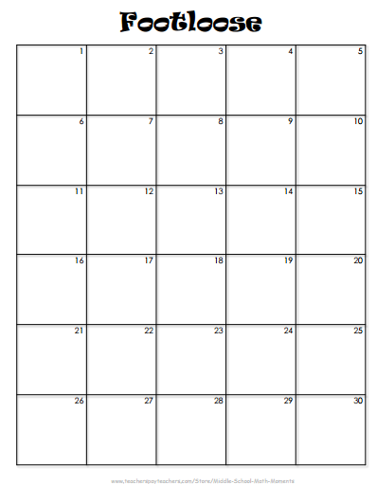

.

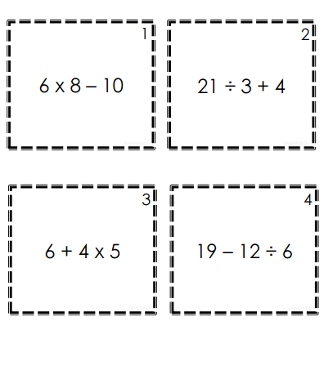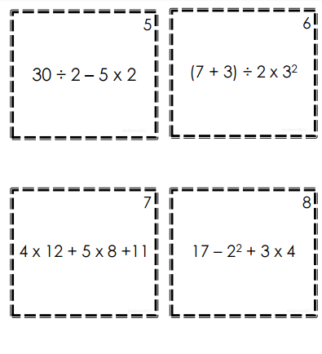

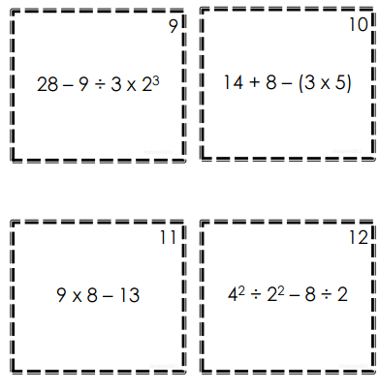

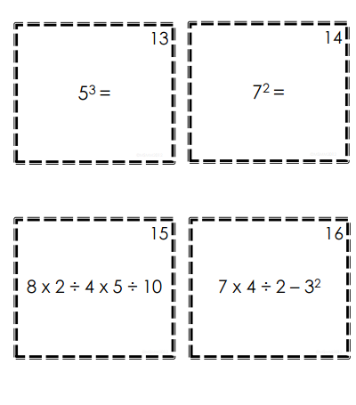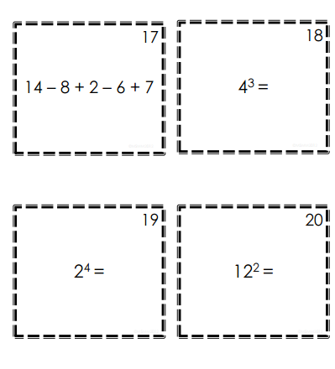

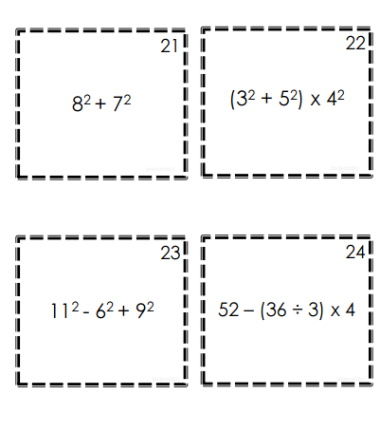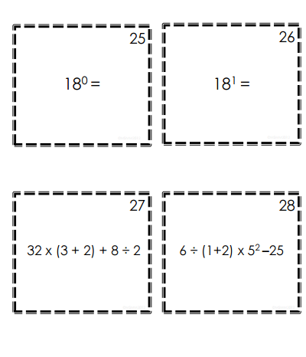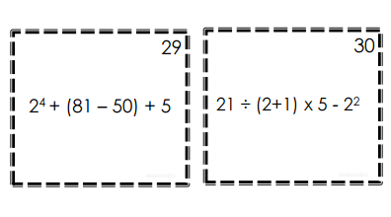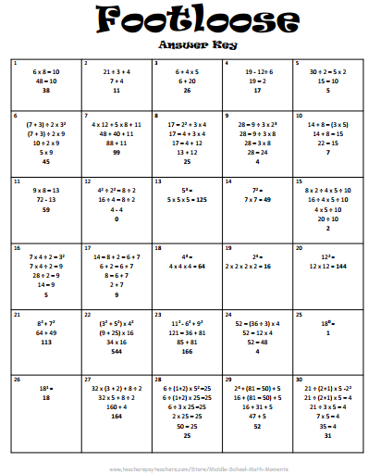

***Order of Operations***

**Objective:** **6.2.2.1** Apply the associative, commutative and distributive properties and order of operations to generate equivalent expressions and to solve problems involving positive rational numbers.

**Launch:** Remind students about Footloose. Today we are going to explore the answers found in the game of footloose they played the previous day.

**Explore:** Students should work together with a partner to check their starting card to be confident that they solved it correctly and are able to explain it to the class. They should ask questions to their partner to make sure they know how to solve their problem.

**Share:** Students will come back together as a class and will take turns explaining the card they started with. They will answer any questions or concerns raised by the class.

**Summarize:** After students have completed their explanations we will review the order of operations and clear up any misconceptions that students still have.

***Mathematical Properties***

**Objective:** **6.2.2.1** Apply the associative, commutative and distributive properties and order of operations to generate equivalent expressions and to solve problems involving positive rational numbers.

**Launch:** Pose the question to the students: How can demonstrate the associative, commutative and distributive properties using pictures and not numbers? (Sample included.) Hand out the worksheet for students to fill in.

**Explore:** Have students work individually to find ways to show the properties with pictures. Students should fill out their worksheets as they go along. When done with the pictures, students should finish the worksheet by coming up with non-examples of the associative, commutative, and distributive properties.

**Share:** Students will share their pictures with their groups and with the help of the group members, students will decide which property picture to draw full size on an 8 ½” x 11” sheet of paper. Students will complete this picture and then take turns sharing them with the whole class.

**Summarize:** Select students to reiterate each of the properties and answer questions and concerns that students still have. Have students share the non-examples of each of the properties.

Sample of Pictorial Representation of Mathematical Properties

Associative Property

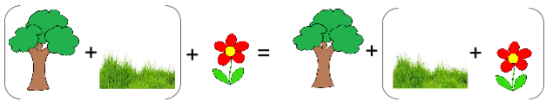

Name: ____________________________________________ Date: ___________

**Use pictures to represent each of the following properties.**

Associative Property

Commutative Property

Distributive Property

**Create a list of 3 or more non-examples for each of the properties**.

Associative Property

Commutative Property

Distributive Property

***Solving Real World Problems***

**Objective:** **6.1.3.5** Estimate solutions to problems with whole numbers, fractions and decimals and use the estimates to assess the reasonableness of results in the context of the problem. **6.2.3.2** Solve equations involving positive rational numbers using number sense, properties of arithmetic and the idea of maintaining equality on both sides of the equation. Interpret a solution in the original context and assess the reasonableness of results.

**Launch:** Pose the question: I have 3 cups of birdseed in a tote. I want to fill up the bird feeders, but I only have a scoop that holds ¾ cup. How many scoops are needed to empty the birdseed? Make a drawing to solve this problem.

**Explore:** Have students do a quick estimate to determine about how many they should come up with. Next have students work individually to come up with a drawing to show this problem and its solution. Next tell the students I have 4 pints of Ben & Jerry’s ice cream. I want to have people over to share it with me. I will give each person ⅔ of a pint. How many people can I serve? Continue with additional problem. I have 3 lb. of fish. I’m going to serve each person ⅔ lb. How many people can be served? What if I had 2 ½ lb. of fish and want to give each person ¾ lb. How many serving will there be?

**Share:** When they are done with each problem have the group members share with each other and see if everyone agrees with each other. If needed, have group members help each other out. Pick the drawing that the group would like to share with the class. One member from each group goes to the board and puts their drawing on the board. Come back together as a large group and have students decide if all the drawings are correct, have them help fix any that are not correct.

**Summarize:** Discuss the importance of visualizing what the problem is asking before you determine how to solve it. Clear up any remaining questions and concerns students have about the solutions to these questions.

**Assignment:** Real-Life Story Problems worksheet

Name: ______________________________________________ Date: ___________

**Real-Life Story Problems**

Draw a picture to solve each problem. Describe what the solution means and if you have a remainder what does that mean?

1. You have 3 yards of ribbon and cut off ½ yard pieces, how many pieces can you cut?
2. How many groups of ¾ are there in 3 ½ circles?
3. You have 1 1/8 cups of m & m candies. You package them into 1/4 cup baggies. How many baggies can you make? Include fraction of a package in your answer.

***Solving Real World Painting Problems***

**Objective:** **6.1.3.5** Estimate solutions to problems with whole numbers, fractions and decimals and use the estimates to assess the reasonableness of results in the context of the problem. **6.2.3.2** Solve equations involving positive rational numbers using number sense, properties of arithmetic and the idea of maintaining equality on both sides of the equation. Interpret a solution in the original context and assess the reasonableness of results.

**Launch:** Review how we solved problems the previous day using pictures. Tell students we are going to do something similar today, but we are going to use connection blocks to model the problems. Pose the problem: My uncle owns a paint company. He can paint 2 rooms a day. If he has 6 rooms to paint, how many days will it take him to paint the rooms? Use the connection blocks to model and solve the problem.

**Explore:** Have students do a quick estimate to determine about how many they should come up with. Next have the students work within their group to come up with a block model to show this problem and its solution. Next tell the students, my uncle just hired a new painter that can paint 3 rooms a day. How many days will it take the new painter to paint the room? Use the connection blocks to model and solve the problem. Pose a new problem, at a different house he has 4 rooms to paint, the painter he has working over there can only do ½ room a day. Use the connection blocks to model how long it will take him to paint the 4 rooms. At yet another house my uncle needs 3 rooms painted. He asked me to paint these rooms. I don’t like to paint so I take lots of breaks and don’t work very fast. I can only paint ¼ of a room a day. Using the connection blocks model how long it will take me to paint the 4 rooms. Now my uncle has decided to paint an additional ½ room in the first house. If the painter he brings in can paint ⅓ of a room a day, use connection blocks to model how long it will take to paint the ½ room. In the last house only ⅓ of a room is left to be painted. He brings back the painter that can paint ½ a room a day, use connection block to model how long it will take this painter to finish painting the ½ room.

**Share:** When they are done with each problem select one group to come up and show and explain their model. If needed, have groups help each other out. As a large group and have students decide if all the models are correct, have them help fix any that are not correct. See if students can come up with any numerical representations to check the models that the groups bring up.

**Summarize:** Have students talk about what was easy and hard about this lesson. Answer any questions students have regarding the models and numerical representations.

***Magic Squares***

**Objective:** **6.2.2.1** Apply the associative, commutative and distributive properties and order of operations to generate equivalent expressions and to solve problems involving positive rational numbers.

**Launch:** Give students tiles numbered 0-9, tell students to use the ones # 1-9 and create a 3 by 3 block where the sum of all rows, columns, and diagonals total to the same number.

**Explore:** Allow students to work individually or with their group to see if they can come up with a 3 by 3 solution. Walk around and guide students as they work through this problem. Remind them of all the sums needed to be a solution.

**Share:** Have students write their solutions on the board. Have discussions about how students found the solutions. What works? What doesn’t work? Have students change to using the tiles 0-8 and have them try again. See if they can come up with solutions. Have students write those on the front board.

**Summarize:** See if students can find patterns between the two. Discuss the different methods used to find the solutions using 0-8 tiles.

**Assignment:** Complete the front side of the Magic Square worksheet and challenge yourself and see how many you can solve on the back. (<http://www.puzzles-to-print.com/number-puzzles/beginner-magic-square-worksheet-1.shtml>)

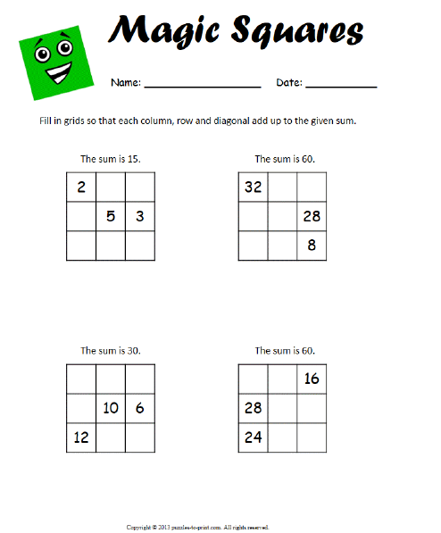

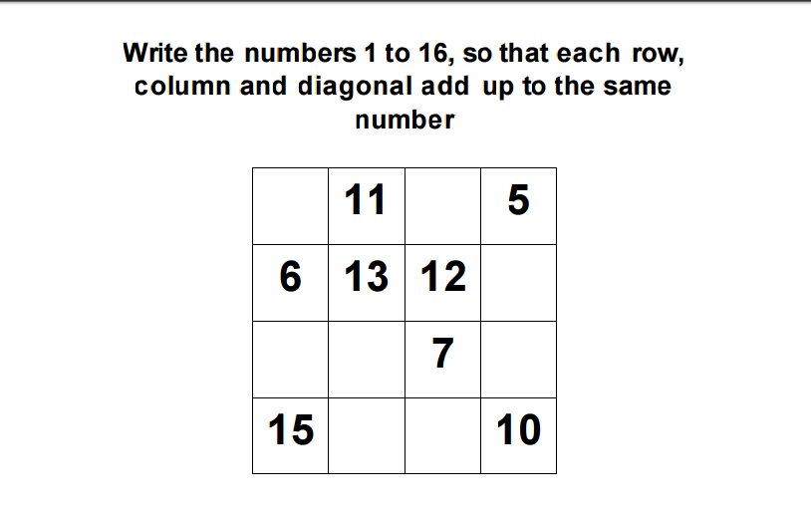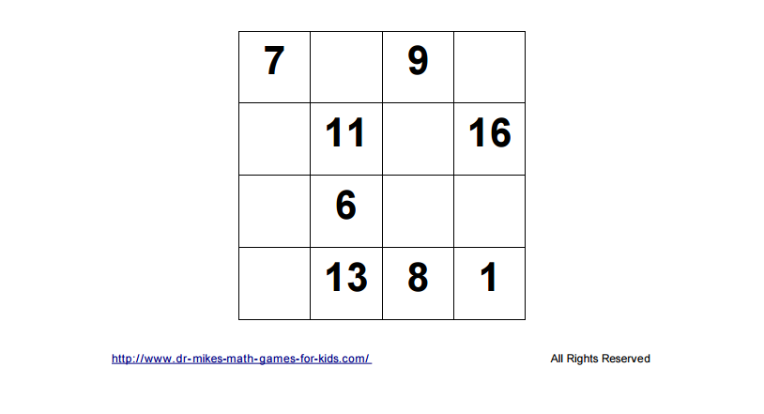

***Magic Squares with Decimals***

**Objective:** **6.2.2.1** Apply the associative, commutative and distributive properties and order of operations to generate equivalent expressions and to solve problems involving positive rational numbers. **6.1.3.4** Solve real-world and mathematical problems requiring arithmetic with decimals, fractions and mixed numbers.

**Launch:** Review Magic Squares. Provide the students with a magic square example with decimals.

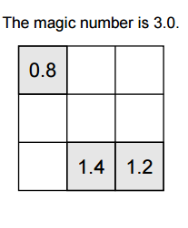

**Explore:** Have students work either individually or with their group to determine the solution for their magic square. Walk around and answer questions that arise.

**Share:** Have a group come to the front and explain how they solved this problem. Discuss the method that was used and the order that they solved them in.

**Summarize:** Discuss the importance of lining up the decimal and making sure the solutions work in all directions. Answer any remaining questions.

**Assignment:** Magic Square: Decimal worksheet (<https://www.worksheetworks.com/puzzles/magic-squares/decimal.html>)

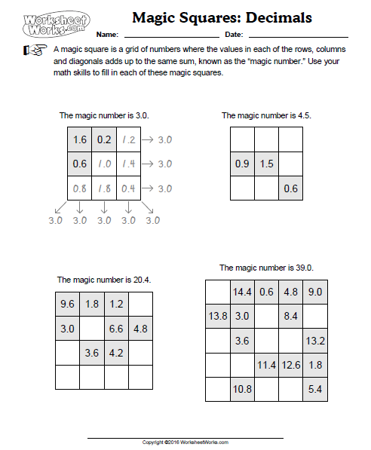

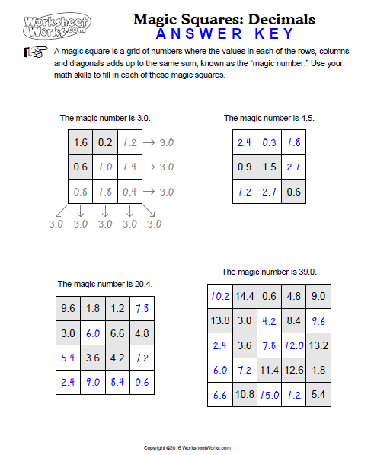

***Cryptarithms***

**Objective:** **6.2.2.1** Apply the associative, commutative and distributive properties and order of operations to generate equivalent expressions and to solve problems involving positive rational numbers.

**Launch:** Pose this problem to the students. Suppose you were given this mathematical problem SO + SO = TOO, can you determine what number is equal to each letter so that the mathematical problem holds true. A couple of rules you need to follow, each letter represents a unique digit and numbers must not start with a zero. Work through this together and discuss the solution to this problem. Next give the students the problem COCA + COLA = OASIS.

**Explore:** Students work in groups to find the solution. Walk around the room answering questions and guiding students to finding the solution.

**Share:** Have one group come to the front and share how they solved the problem. Answer any questions that come up.

**Summarize:** Discuss how we know where to start and why it’s important to work together to solve this. Students need to focus on attributes of the base ten place value system -- look for regrouping, even numbers, repeats, 1’s, 9’s, and 0’s in the solution. This one problem provides students with multiple opportunities to work on their addition skills while providing a fun way to do this.

**Assignment:** Cryptarithms worksheet

Name: _________________________________________________ Date: _________

**Cryptarithms**

See how many of the following cryptarithms you can solve.

1. 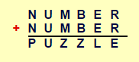 2. 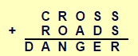

3. 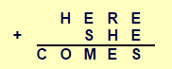 4. 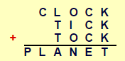

Name: _________________________________________________ Date: _________

**Cryptarithms - ANSWER KEY**

See how many of the following cryptarithms you can solve.

1. 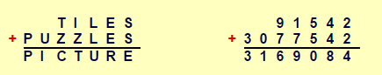
2. 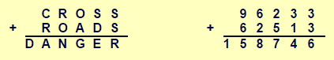
3. 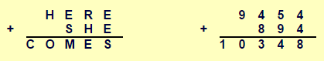
4. 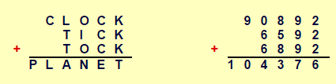

**Number Theory Post-Test**

1. Find all the factors for these integers:

24: _____________________________________________________________

56: _____________________________________________________________

96: _____________________________________________________________

2. Use a factor tree and write out the prime factorization of 228

3. Find the Greatest Common Factor for these sets of integers.

36, 48:

84, 126:

32, 56:

4. Find the Least Common Multiple for these sets of integers.

3, 24:

4, 5:

7, 9:

5. Compare these rational numbers:

1. 3/7 _____ 2/6 2. 0.08 _____ 0.8 3. 65% _____ 56%

4. ⅕ ____ 20% 5. 35% _____ 0.35 6. 0.50 _____ 25/50

6. Order these rational numbers from least to greatest:

65/100, 64%, 0.6

________________________________________________________________

46%, 7/13, 0.42

________________________________________________________________

1.23, 9/10, 95%

________________________________________________________________

7. You have of 2 ½ pounds of skittles. You put together small bags each weighing ⅓ of a pound. How many bags did you make? Draw a picture to solve and explain what your solution and any remainders means.

8. Solve

9. Name the property shown in each example.

____________________________________

____________________________________

____________________________________

10. Fill in missing numbers.



11. Write a story using hot and cold cubes. Draw a picture and show our solution.

12. Solve

